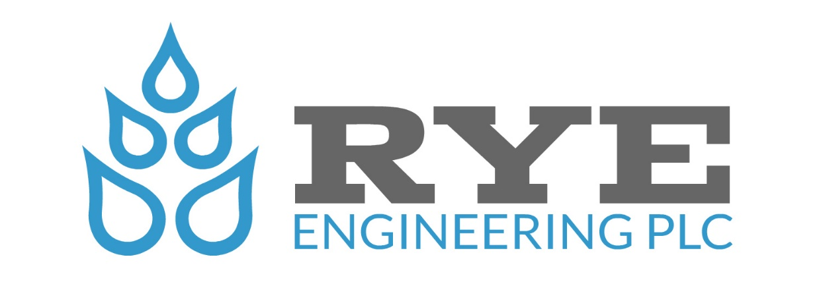

Bass Challenge at Kentucky Lake
Tournament Itinerary

Location: Paris Landing State Park & Marina, Buchanan, Tennessee.
Date: May 13th, 2022.
On-Site Registration & Breakfast Begins: 4:30 a.m.
Pre-Tournament Meeting: 5:00 a.m.
Blastoff: 5:48 a.m. or Safe Light
Weigh-In: 3:00 p.m.
Hotel Headquarters: Fish Tale Lodge: (Reservations) (731)642-7113
Fish Tale Lodge provides electrical outlet for battery charging at your room.
Hotel Room Cutoff Date: N/A

Bass Types: Largemouth 15in., Smallmouth 15in., Spotted Bass (no length limit)
Bass Limit: 5
Tournament On-Line Registration Cutoff Date: May 10th, 10:00 a.m. Central Time.

Special Notes of Interest: At this time, no per-tournament dinner is scheduled. However, we will notify participants by text if a planned event is scheduled. There are a variety of restaurants to choose from in the area: Blues Landing, Marker 66 at Paris Landing Marina, Fish Tale Lodge (Meo Mio’s), Carmelita’s Comida Mexicana, Cherokee Hill’s Ranch, TNT Pizza, Lakeview Grille and Dockside Bar & Grill.

Special Note: The New Inn at Paris Landing State Park in scheduled to open in the spring of 2022. Parties wishing to use and stay at the new facility should check with Paris Landing State Park for updates and accommodations.

